**Tamarind Juice**

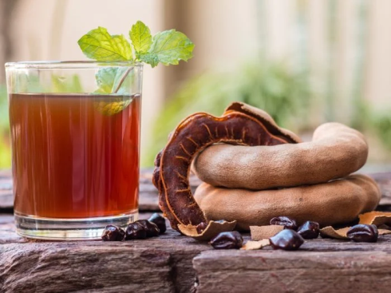

**INGREDIENTS**

8 cups water

1 1/2 cup sugar

2 cups of ripe tamarind pods (not the green ones)

A thumb piece of ginger or 1 tsp of ground ginger

**METHOD**

1. Shell and divide the tamarind pods till you have 2 cups of tamarind pods
2. In a saucepan over medium heat, combine the tamarind, ginger, and 3 cups of water
3. Bring to a simmer, stirring and mashing with the back of a spoon until softened and the mixture is thickened. The flesh will have started to peel away from the seeds.
4. Remove from heat and let cool
5. Use a fine-mesh sieve to extract the pulp into a pitcher using the back of a spoon to help extract the pulp. Then add the remaining 5 cups of water to the pitcher
6. Sweeten to taste with sugar, and serve over ice. Enjoy!